Data Representation
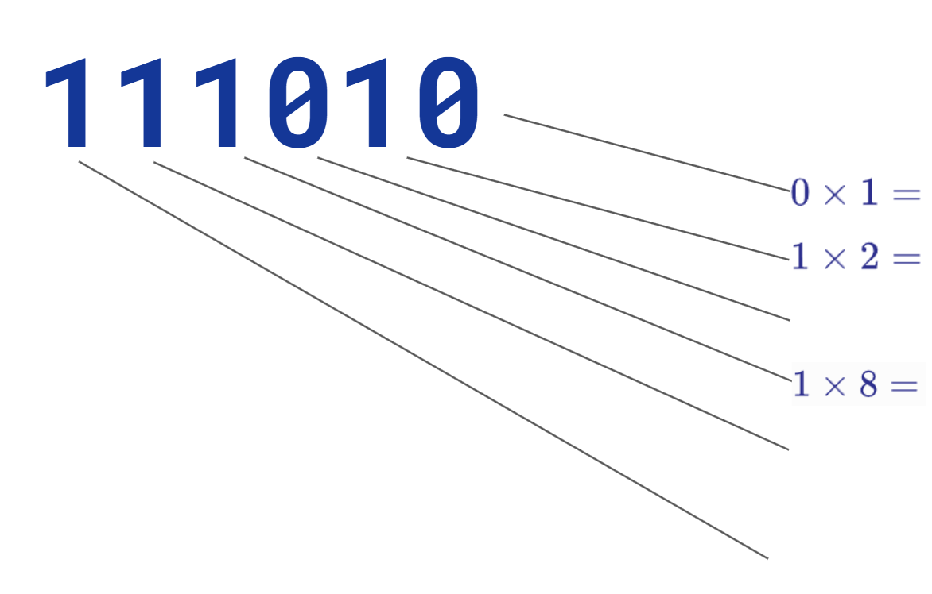
Practise NOWWWWWW
0001 | 0011 | 0101 | 1000
1110 | 1101 | 1100 | 0100
1001 | 0000 | 0111 | 0010
1011 | 0110 | 1010 | 1111

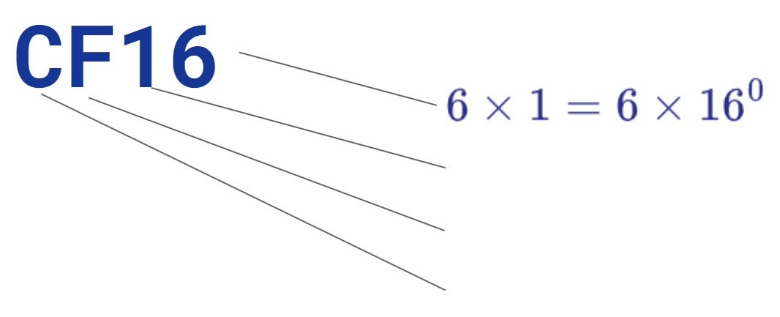
Decimal Quotient Remainder  135 | Decimal Quotient Remainder  2663 2663/16 = 166 7=7  166 166/16 = 10 6=6  10 16/16=0 10=A

